EXPT NO: 5 | IMPLEMENTATION OF A RECURRENT NEURAL NETWORK (RNN) FOR TEXT GENERATION
DATE:

PRE-LAB QUESTIONS (PROVIDE BRIEF ANSWERS TO THE FOLLOWING QUESTIONS)

- Explain the purpose of a Recurrent Neural Network (RNN) in processing sequential data.
An RNN is designed to process sequential data by maintaining information from previous elements through its hidden state. This allows it to learn dependencies between earlier and later elements in a sequence.

- Why is an RNN considered an appropriate model for text generation tasks?
Text is naturally sequential, where each word depends on the previous words. An RNN learns these relationships and predicts the next word based on the context of earlier words, making it suitable for text generation.

- Describe the concept of sequence modeling in natural language processing.
Sequence modeling involves learning the relationships and order among words in a sentence. In NLP, it is used for tasks such as text generation, language translation, and speech recognition.

- Explain the importance of tokenization during text preprocessing for RNN-based text generation.
Tokenization splits text into individual words or tokens. It converts raw text into manageable units that can later be mapped to numerical values for input to the RNN.

- Explain the significance of converting text into numerical representations before training an RNN.
Neural networks cannot directly process text. Therefore, words are converted into integer indices or vector representations so that the RNN can perform mathematical computations during training.

AIM
To implement a Recurrent Neural Network (RNN) for text generation and evaluate its ability to generate meaningful text by predicting the next word in a sequence.

SOFTWARE REQUIREMENTS
- Python
- TensorFlow or keras or PyTorch
- Google Colab
- GitHub
- Numpy
- Matplotlib

OBJECTIVES
Students will be able to:
- Understand the architecture and working of Recurrent Neural Networks (RNNs).
- Perform text preprocessing techniques for sequence modeling.
- Generate input sequences suitable for training an RNN model.
- Build and train an RNN model for text generation.
- Generate text by predicting the next word in a sequence.
- Evaluate the performance of the trained RNN using generated text.
- Analyze the effectiveness of RNNs in learning sequential patterns from textual data.

PROCEDURE
PART A: DATASET PREPARATION
Perform the following tasks:
- Load the Tiny Shakespeare dataset from Hugging Face.
- Explore the dataset and examine the text samples.
- Convert the text into lowercase (if required).
- Tokenize the text into individual words.
- Build a vocabulary and assign a unique integer index to each word.
- Generate input sequences for next-word prediction.
- Apply sequence padding to obtain inputs of equal length.
- Split the prepared sequences into training and validation datasets.

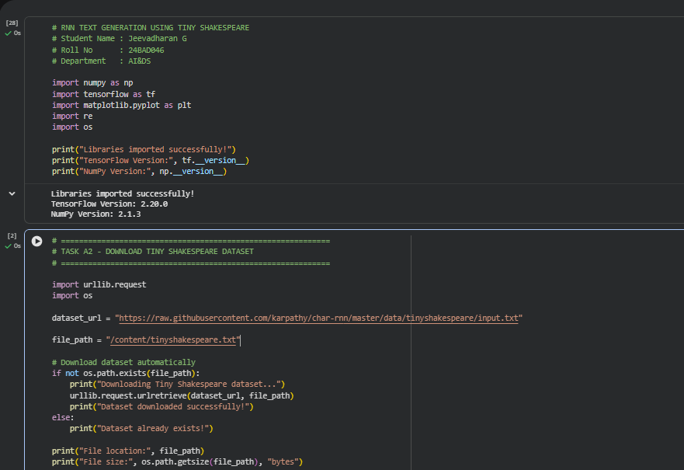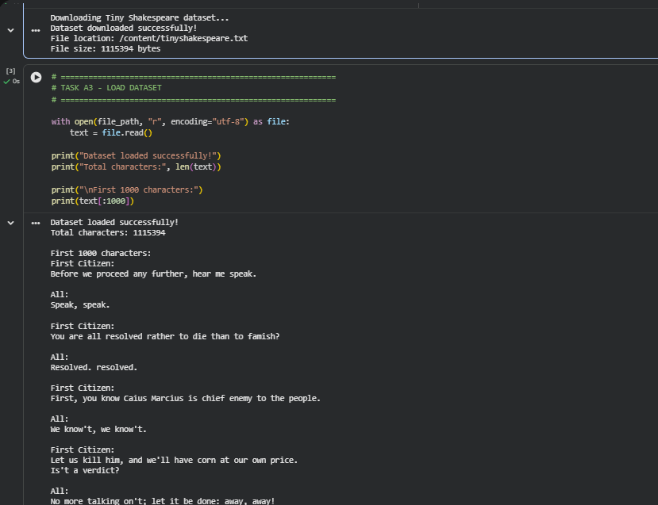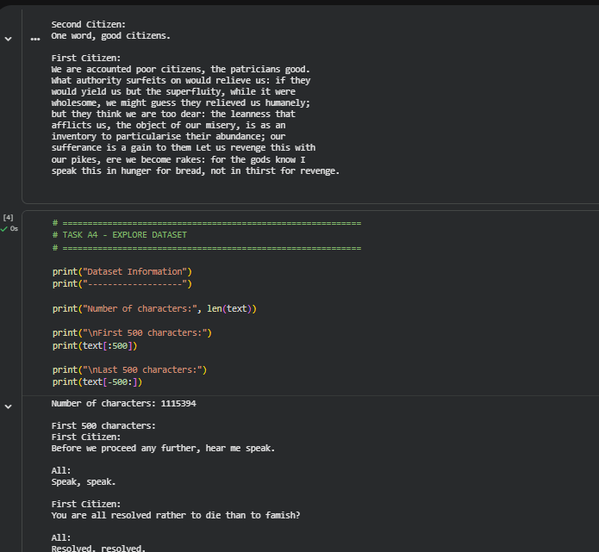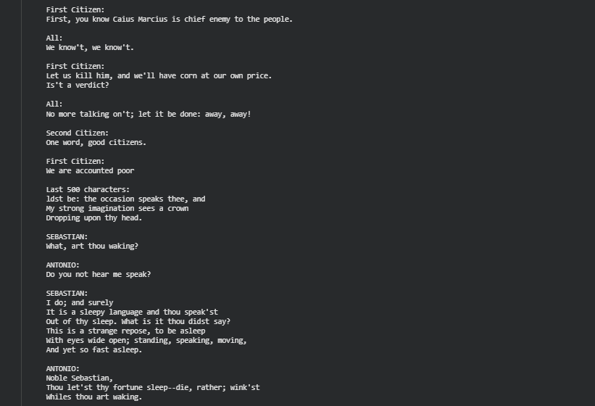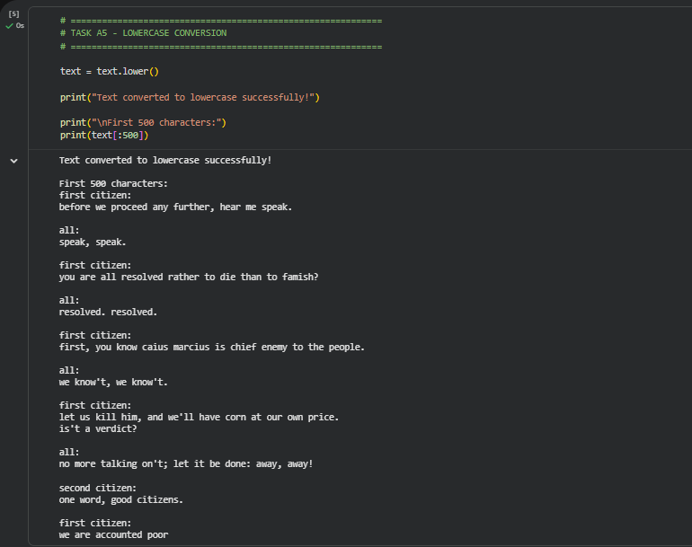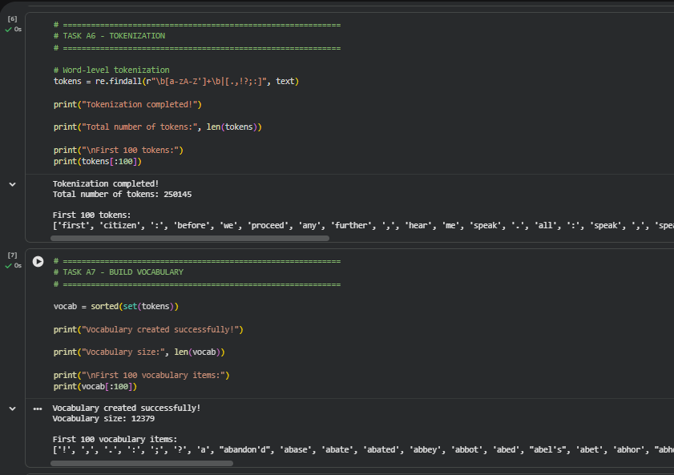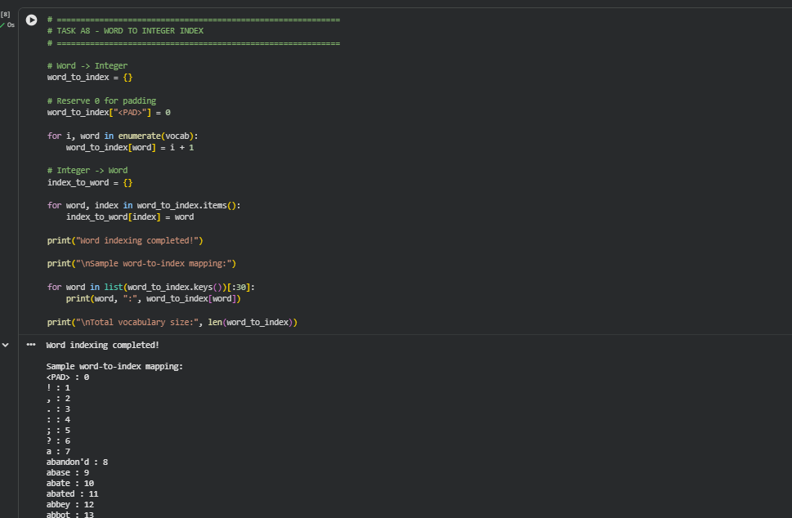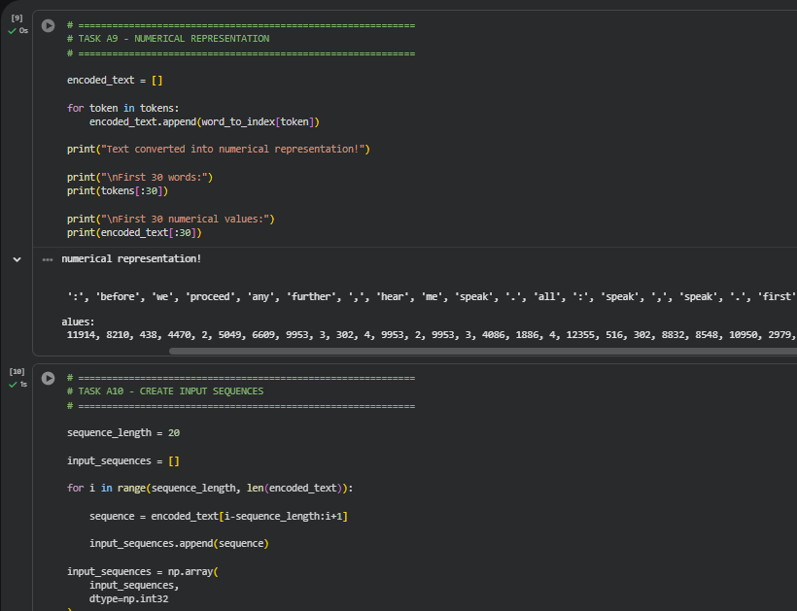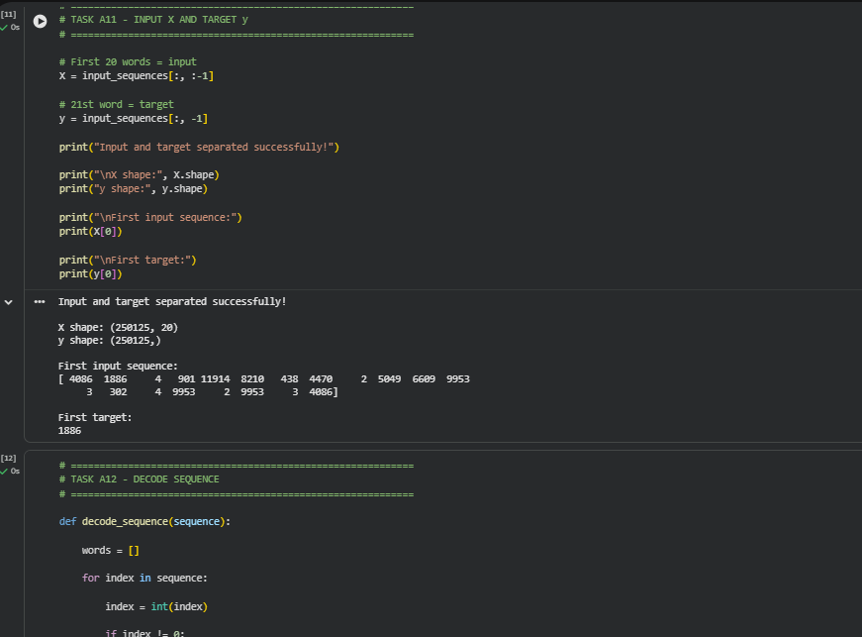
PART B: IMPLEMENTING THE RNN MODEL
Perform the following tasks:
- Create an Embedding layer to convert words into dense vector representations.
- Add a Simple RNN layer to learn sequential dependencies in the text.
- Add a Dense output layer with Softmax activation for next-word prediction.
- Compile the model using an appropriate optimizer and loss function.
- Display the model architecture and summary.

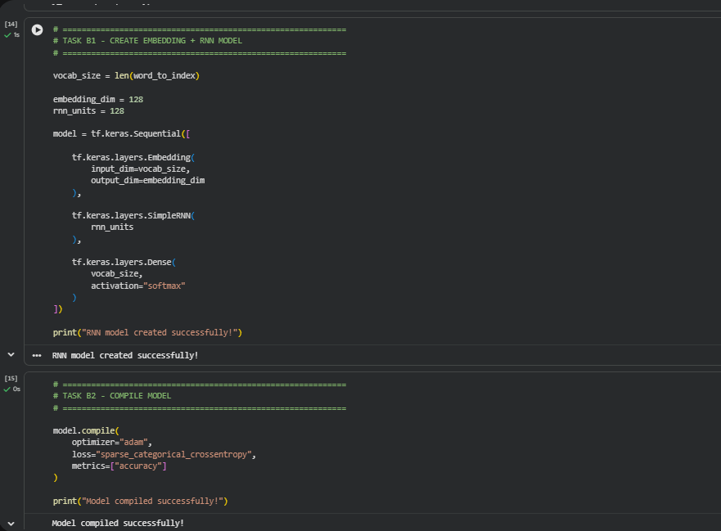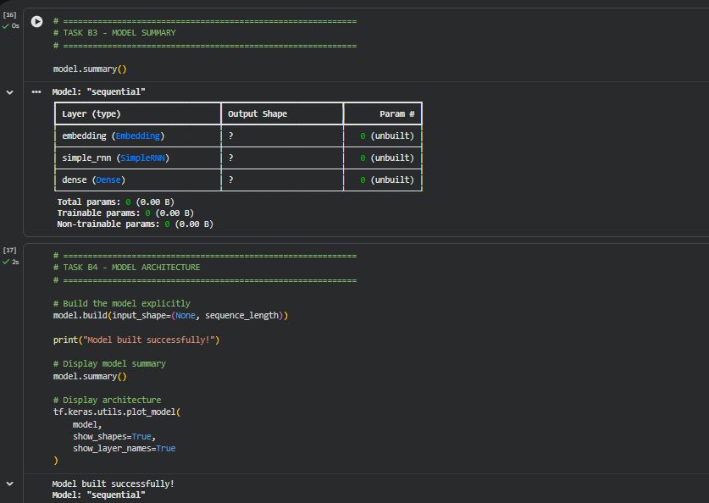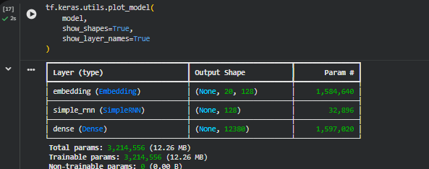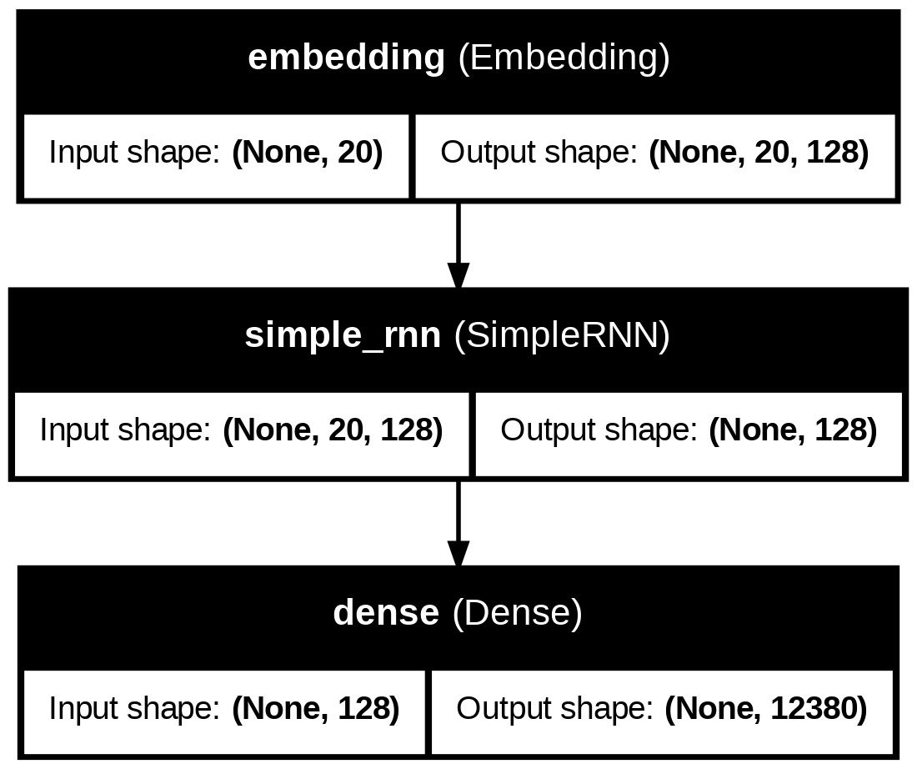
PART C: COMPARISON OF OPTIMIZATION ALGORITHMS
Perform the following tasks:
- Train the RNN model using the prepared training dataset.
- Validate the model using the validation dataset.
- Record:
  - Training accuracy
  - Validation accuracy
  - Training loss
  - Validation loss
- Visualize:
  - Accuracy vs. Epoch
  - Loss vs. Epoch
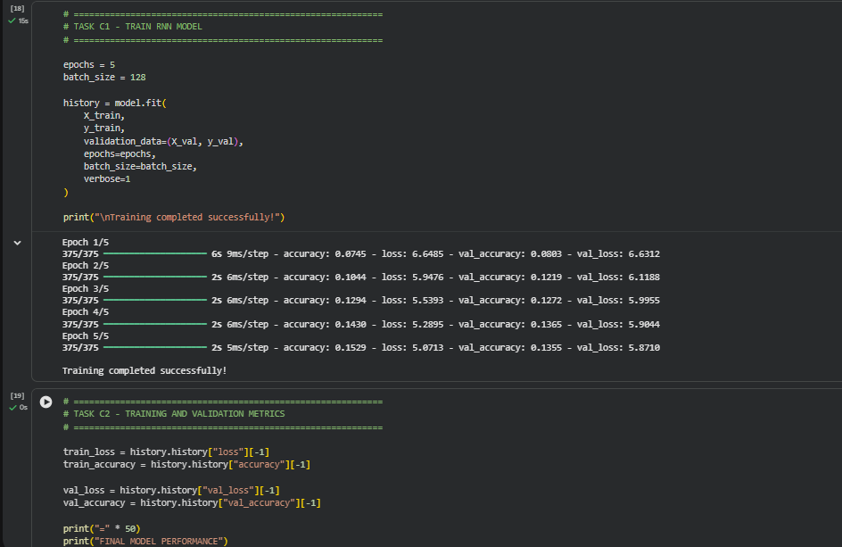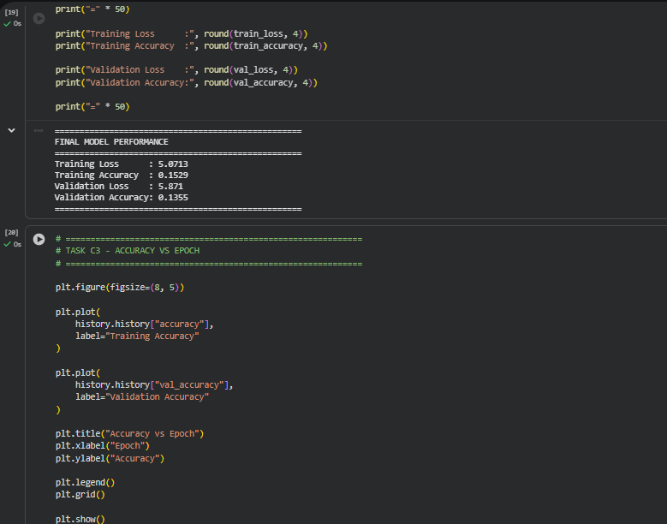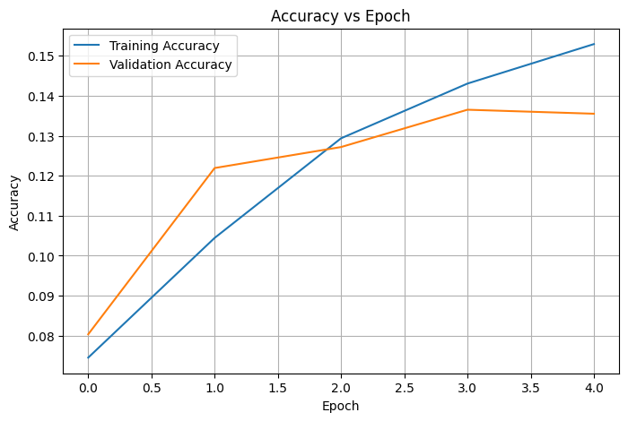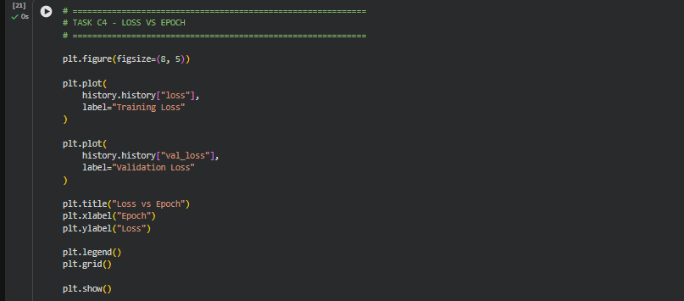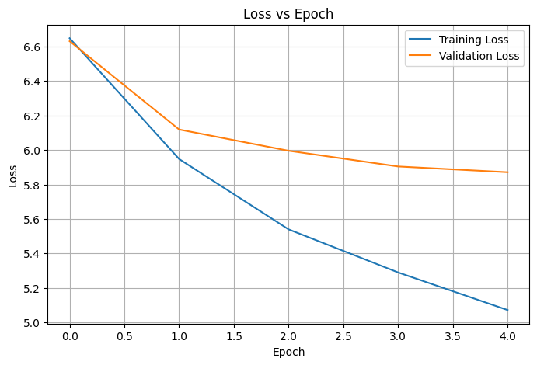
PART D: DEEP LEARNING EXPERIMENT MANAGEMENT
Perform the following tasks:
- Provide a seed word or sentence as input to the trained model.
- Generate text by repeatedly predicting the next word in the sequence.
- Produce multiple text samples using different seed inputs.
- Compare the generated text for coherence and contextual relevance.
- Document the observations and upload the notebook to GitHub.

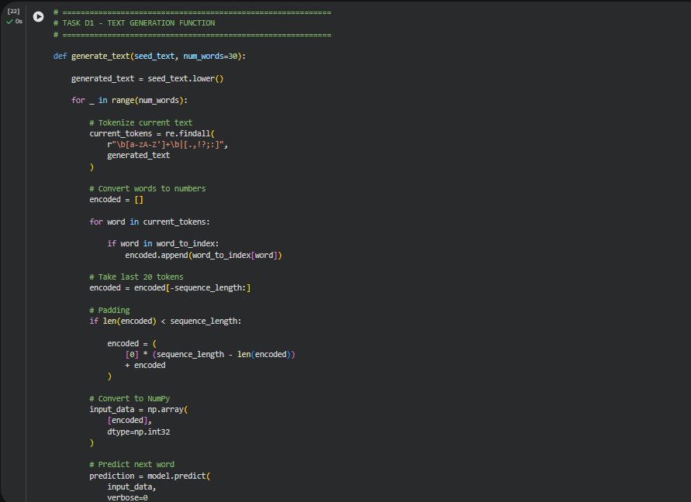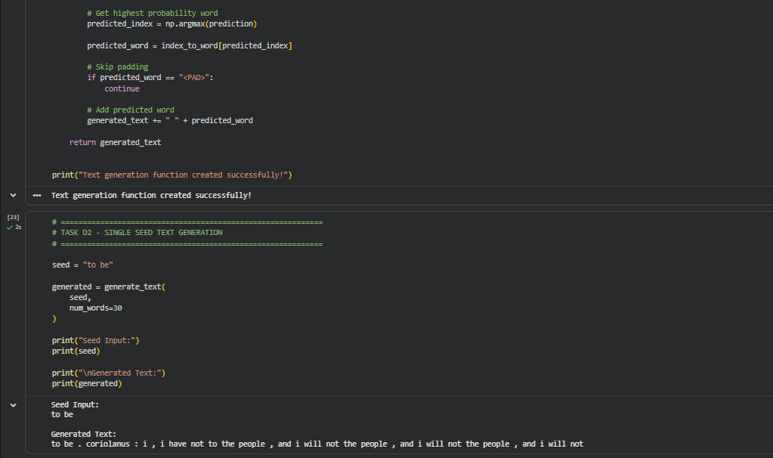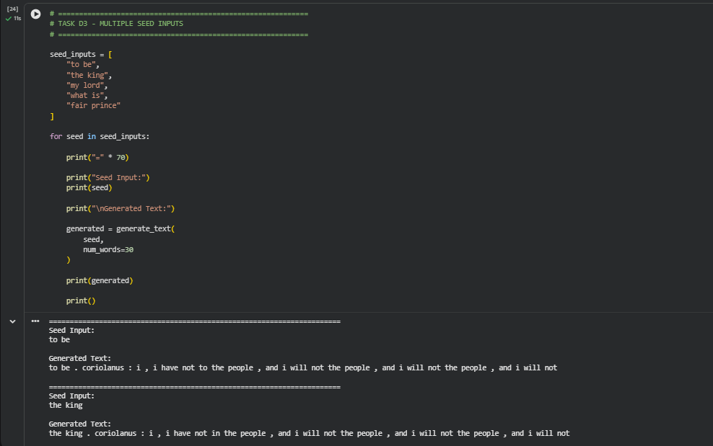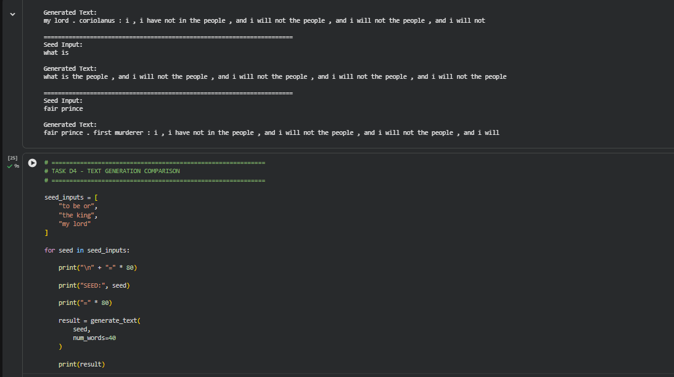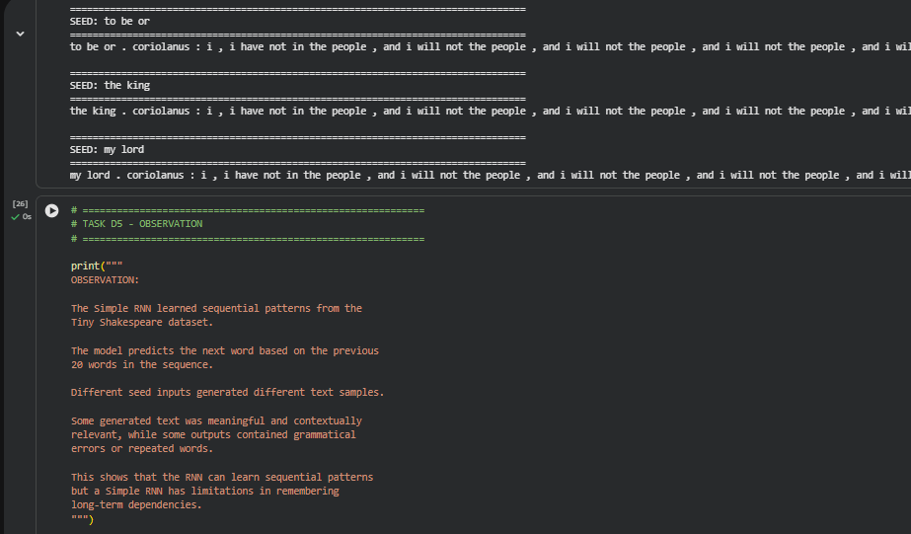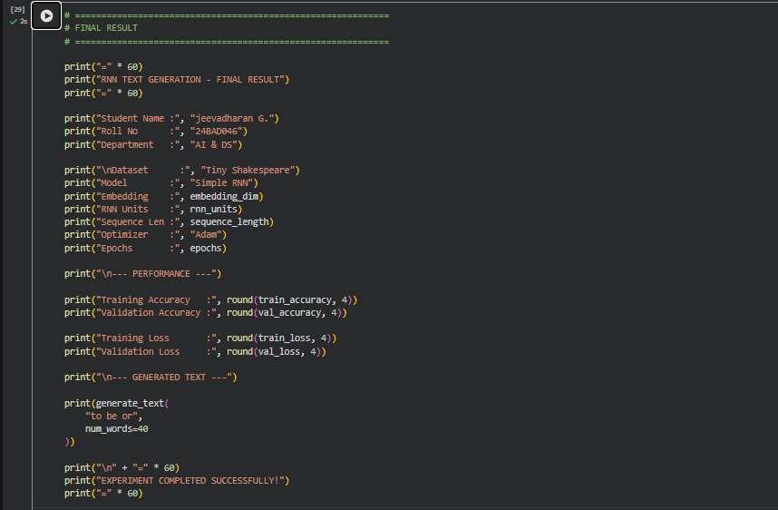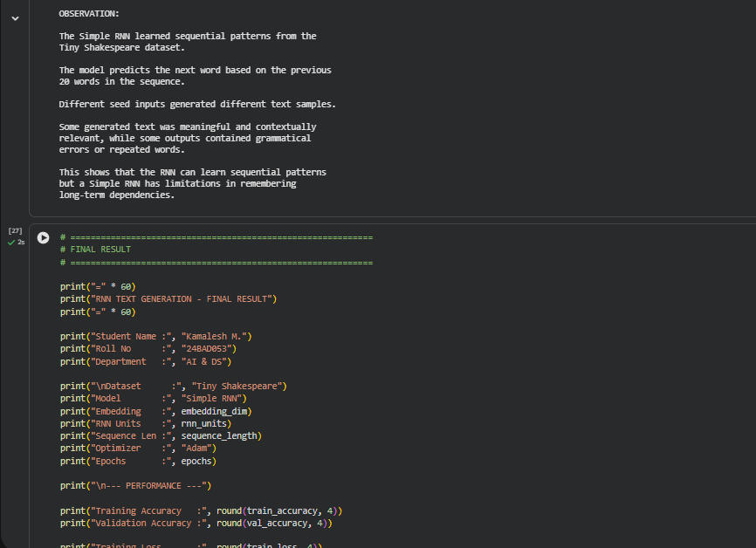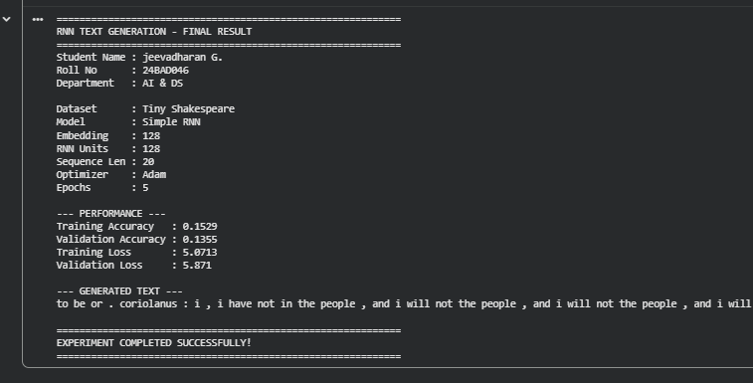

EXPECTED OUTCOME
Students will understand how an RNN learns sequential information and generates meaningful text based on previously learned patterns. Students will learn to preprocess textual data and train a Recurrent Neural Network (RNN) for text generation. They will evaluate the model's performance using training metrics and generate text through next-word prediction.

POST-LAB QUESTIONS (PROVIDE BRIEF ANSWERS TO THE FOLLOWING QUESTIONS)

- Describe the role of the hidden state in an RNN during sequence processing.
The hidden state stores information from previous time steps and carries it forward through the sequence. It acts as the memory of the RNN and helps capture contextual relationships between words.

- Discuss the effect of training an RNN model for an insufficient number of epochs.
If the model is trained for too few epochs, it may not learn the patterns in the training data properly. This results in underfitting, low accuracy, and poor-quality generated text.

- Explain the purpose of padding when preparing text sequences for RNN training.
Padding makes all input sequences the same length by adding special values, usually zeros. This allows the sequences to be processed efficiently in batches by the RNN.

- Discuss one limitation of a Simple RNN when processing long text sequences.
A Simple RNN suffers from the vanishing gradient problem, making it difficult to remember information from distant parts of long sequences. As a result, it may fail to capture long-term dependencies.

- Discuss the effect of sequence length on the performance of the text generation model.
A longer sequence provides more context, which can improve text generation. However, very long sequences increase computational cost and may make training more difficult, especially for Simple RNNs.

ASSESSMENT
Description | Max Marks | Marks Awarded
Pre Lab Exercise | 5
In Lab Exercise | 10
Post Lab Exercise | 5
Viva | 10
Total | 30
Faculty Signature

